2310030239 Csp.Bharat

Ci-cd Lab exam

Question: Create an IAM user who should have EC2 access through policy and S3 though group.

1. Create IAM User  
  
Sign in to AWS Console  
Search and open IAM  
Click Users - Add user

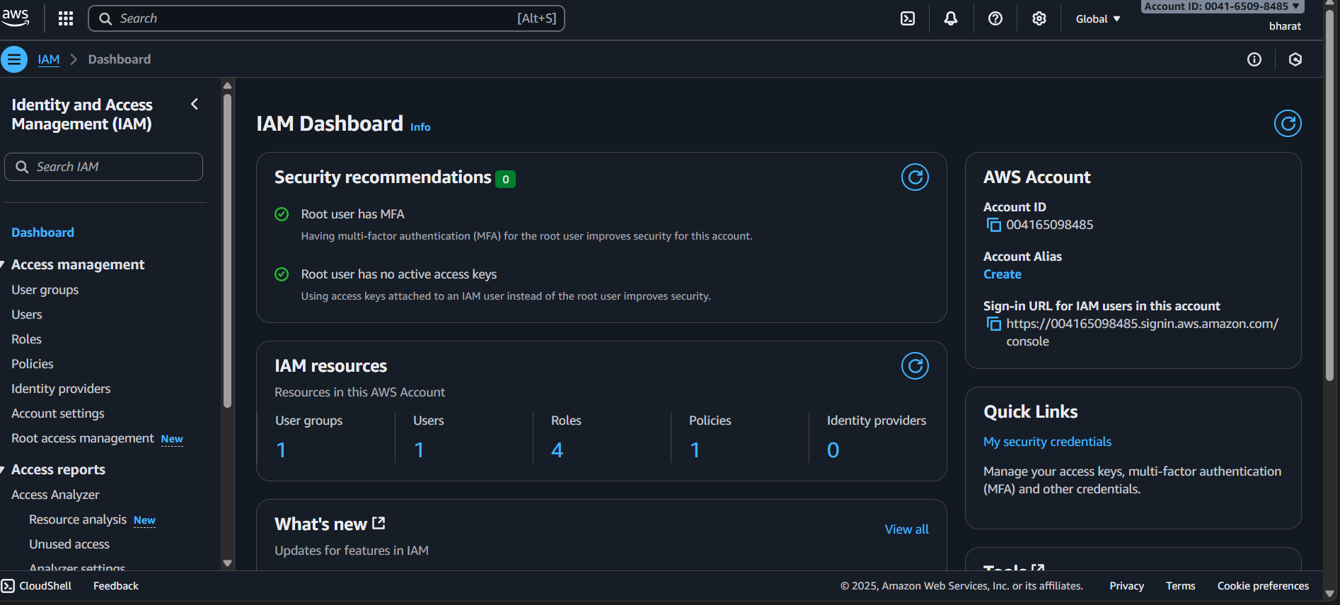

2.Create IAM Group for S3 Access  
  
In IAM, click User groups  
Click Create group  
Name group: S3AccessGroup  
Attach AmazonS3FullAccess policy  
Click Create group

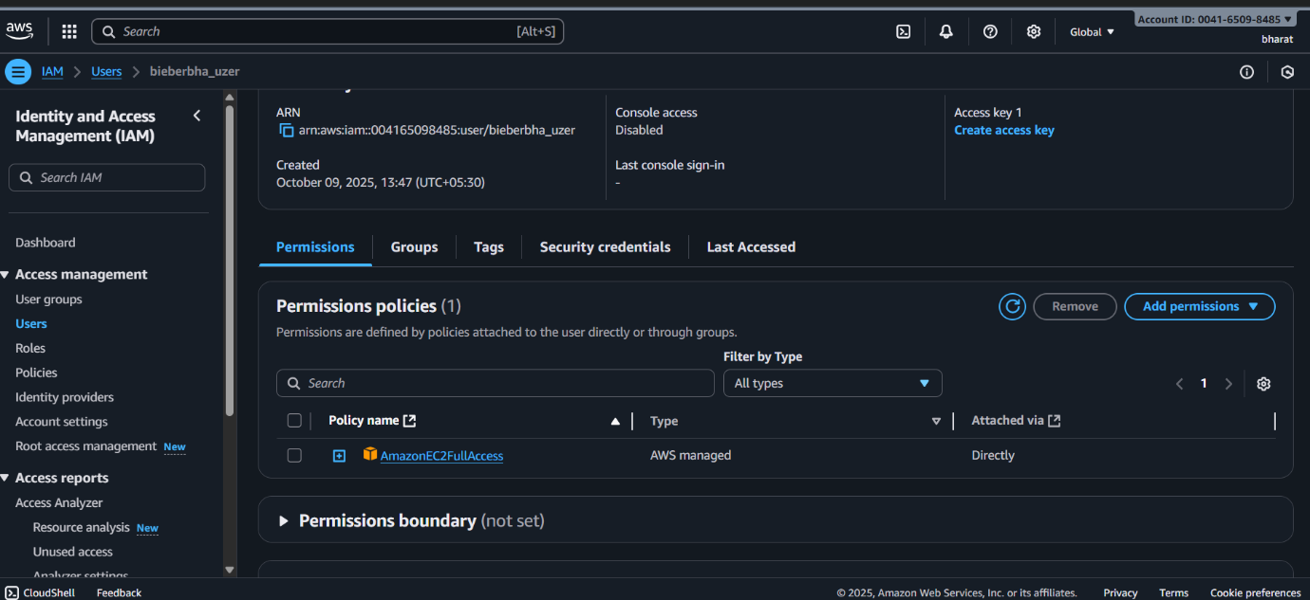

3. Add User to Group  
  
Open group S3AccessGroup  
Go to Users tab  
Click Add users  
Select ec2-s3-user  
Click Add users

